Guide for Online BEAR Submissions
How to Submit an Online BEAR
Important: To submit a BEAR Form online, applicants will need their PIN, AND their service provider must be accepting Online BEARs. If a vendor is not accepting Online BEARs, the applicant must file a paper BEAR (Hint: If you’re unsure, call your vendor to find out before you begin this process. There is no website or list to show which vendors accept Online BEARs, unfortunately).
1) Log-in to the Online BEAR System at: https://www2.sl.universalservice.org/bear/login.aspx using your Billed Entity Number (BEN), PIN, email address, and the last name of the PIN user. (If the system says it's an invalid e-mail address, try typing it in CAPs, or try using the last name of the contact person.) Unlike all other SLD forms, the Online BEAR requires you to log-in using your PIN instead of certifying the form after it's been submitted.
2) Click on “New BEAR Form” at the top of the page to start a new BEAR. (If you ever want to track a BEAR that's been submitted (even previously submitted paper-submitted BEARs) or is pending, instead click on "Track Form" and enter the query information.)
3) When the blank BEAR Form appears:
Enter the Applicant Form Identifier
# 3: Enter the SPIN for this BEAR (remember a BEAR can only be associated with 1 SPIN)
# 7: Enter the Form 471 Number
# 8: Enter the FRN Number
# 10 (Use for recurring services and skip # 11): The date for # 10 should be the date of the first bill that you received from the service provider for the reimbursements being requested on this BEAR. For example, if you are filing for 12 months worth of bills, your first bill likely was 7/1/2013 or some date in July 2013. If you are only filing for reimbursement on bills from January 2014 - June 2014, your bill date would likely be 1/1/2014 or some date in January 2014.
# 11: (Use ONLY for non-recurring services and skip # 10): The date in # 11 should be the date that the products were shipped, the last date that the service provider performed its work, or the vendor bill date.
#12: Enter the eligible pre-discount amount spent for this FRN.
#13: Enter the approved discount rate for this FRN.
The online system will then automatically multiply the amount in # 14 by the discount rate you have cited in # 13, and populate that product in # 15.
Note: If you have more than 1 FRN for this SPIN, you may click "Add Line Item" at the bottom of Block 2 to enter the new FRN information on the same BEAR.
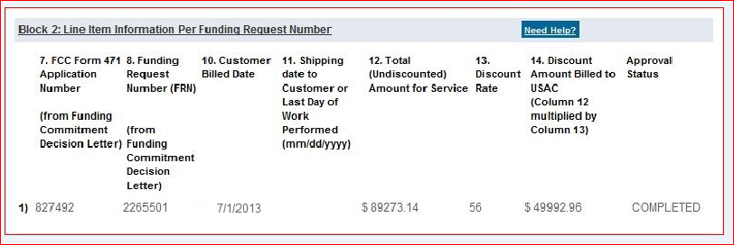
4) Block 3 Certifications:
A, B, C, D, E: Check the box to the left of each certification.
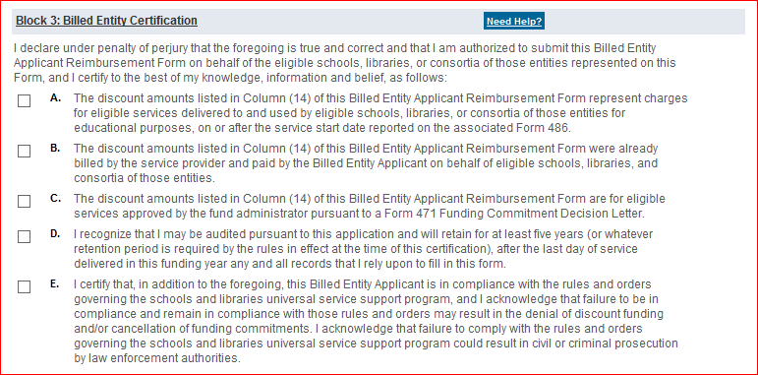
# 15: Check the signature box.
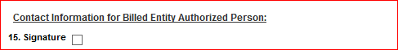
# 18 - 20: Enter the authorized person’s contact information.
5) Block 4, Item 27 – Remittance Information. The applicant should write in the name and title of the person to whom the reimbursement check should be mailed and the contact person’s address. This person should be an employee of the applicant and not a third party such as a consultant.
6) When you have reviewed and verified all of the information on the form, click the “Certify and Submit” button at the bottom of the form. Your service provider will automatically receive an email notification that your form is available to be reviewed and certified. USAC also will send you a copy of that notification. It is also be a good idea to email your service provider to let them know you have submitted a BEAR that needs to be certified (just in case the USAC email does not reach the service provider).
7) If…..
… your service provider certifies your BEAR, you will receive an e-mail that the form has been vendor-certified and has been electronically sent to USAC for payment.
… your service provider does not certify your form within 15 days, USAC will cancel your BEAR Form and send a notice of cancellation by email to both you and the service provider.
...your service provider denies your BEAR, you should contact them to find out the reason, and then resubmit a new BEAR.
…you entered more than one line item, and if your service provider does not certify all of them, you must file a new BEAR Form for the line(s) that were not certified. (Your service provider has the option of certifying the entire BEAR Form or just certifying certain lines on that form.)
Unfortunately, it's not possible to amend a submitted BEAR, or open a previously submitted or pending BEAR, and make revisions. You must file a new BEAR Form to request reimbursement.
8) After the service provider certifies the BEAR, it typically will take USAC 1-2 weeks to process it, and if it's approved, you'll receive a Form 472 Approval Letter and USAC will remit electronic payment to the service provider within 20 calendar days. The service provider then must mail you a check within 20 business days.

